<Titel of Thesis>
Bachelor project thesis| Master project thesis| Bachelor term paper| Master term paper| Bachelor thesis - exposé | Bachelor thesis| Master thesis -exposé | Master thesis (please delete inappropriate terms)

Presented to the Faculty of Informatics
of University Duisburg-Essen

<First name> <last name>
<address line>
<postal code> <city>
Matrikelnr: <Matrikelnr>
Course of Study: <Course of Study>

Reviewer: <First reviewer>
<Second reviewer>
Semester of study: <Current semester>
<Completed semesters>

Confidentially Clause
This thesis contains confidential data of <Name der Firma, die auf die Vertraulichkeitserklärung besteht>. Any publication or duplication of this thesis – even in part – is prohibited, excluding cases with explicit permission by <Name der Firma, die auf die Vertraulichkeitserklärung besteht>. The thesis is to be made accessible only to the staff of the research group supervising it and the board of examiners.

Sperrvermerk
Die vorliegende Abschlussarbeit enthält vertrauliche Informationen der <Name der Firma, die auf die Vertraulichkeitserklärung besteht>, die der Geheimhaltung unterliegen. Veröffentlichungen oder Vervielfältigungen der Abschlussarbeit – auch nur auszugsweise – sind ohne ausdrückliche Genehmigung der <Name der Firma, die auf die Vertraulichkeitserklärung besteht> nicht gestattet. Die Abschlussarbeit ist nur den Mitarbeitern des betreuenden Lehrstuhls sowie den Mitgliedern des Prüfungsausschusses zugänglich zu machen.

Place, date, signature

Table of Contents
List of Abbreviations II
List of Figures III
List of Tables IV
1 Introduction 1
1.1 Motivation 1
1.2 Problem Definition 1
1.3 Objectives of Thesis and Research Question 1
1.4 Scientific Approach 1
2 <Fundamentals/ State-of-the-Art> 2
2.1 <Fundamentals 1: Tables> 2
2.2 <Fundamentals 2: Figures> 2
3 <Main Chapter> 3
3.1 <First sub-chapter> 3
3.1.1 <First sub-sub-chapter of your sub-chapter> 3
3.1.2 <Second sub-sub-chapter of your sub-chapter> 3
3.2 <Second sub-chapter> 3
4 Conclusion 4
4.1 Discussion 4
4.2 Critical Appraisal 4
4.3 Future Work 4
Bibliography 5
Appendix 6
Appendix 1 <Name of what is appended> 6

List of Abbreviations
ERP Enterprise Resource Planning
IT Information Technology

List of Figures
Figure 1: IS Success Model 2

List of Tables
Table 1: This is an exemplary table 2

Introduction
The suggested structure serves only as an example! Be aware that the structure of your introduction may vary depending on the topic of your thesis.

Motivation

Objectives of Thesis and Research Question

Structure of the Thesis

<Background / State-of-the-Art>
Here, you describe the current body of knowledge that is relevant for your thesis. This can also be supported by using tables or figures.

<Fundamentals 1: Tables>
Exemplary Table:
Column 1 | Column 2 | Column 3
Line 1 | A | AA
line 2 | AB | …
Line 3 | …
Table 1: This is an exemplary table
And here you write your text and refer to Table 1 as you describe what is depicted.

<Fundamentals 2: Figures>
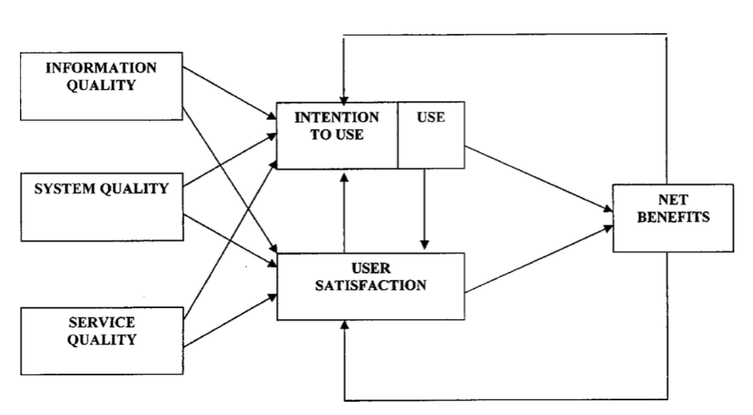
As you see, Figures are handled according to tables:
Figure 1: IS Success Model
Source: DeLone und McLean (2003)
If you want to avoid that your figures and their legends separate from one another, you should use the function of “Gruppieren”/”Group”, namely grouping them into one object.

<Research Method>

<First sub-chapter>

<First sub-sub-chapter of your sub-chapter>

<Second sub-sub-chapter of your sub-chapter>

<Second sub-chapter>

<Results>

<First sub-chapter>

<First sub-sub-chapter of your sub-chapter>

<Second sub-sub-chapter of your sub-chapter>

<Second sub-chapter>

<Discussion>
This typically includes answering your research question by shortly reflecting your main findings. Furthermore, the implications of your findings and their contribution to the body of knowledge should be thought of.

<First sub-chapter>

<First sub-sub-chapter of your sub-chapter>

<Second sub-sub-chapter of your sub-chapter>

<Second sub-chapter>

Conclusion

Summary

Limitations
Here, you mainly address the limitations of your thesis and how they may have influenced your results.

Future Work

Bibliography
DeLone, W.H.; McLean, E.R. (2003): The DeLone and McLean Model of Information Systems Success: A Ten-Year Update. In: Journal of Management Information Systems, 19 (4), p. 9-30.

Appendix
- <Name of what is appended>

Statutory Declaration
The statutory declaration needs to be in German, so the following excerpt is in German:

Eidesstattliche Erklärung
Ich versichere an Eides statt durch meine Unterschrift, dass ich die vorstehende Arbeit selbständig und ohne fremde Hilfe angefertigt und alle Stellen, die ich wörtlich oder annähernd wörtlich aus Veröffentlichungen entnommen habe, als solche kenntlich gemacht habe, mich auch keiner anderen als der angegebenen Literatur oder sonstiger Hilfsmittel bedient habe. Die Arbeit hat in dieser oder ähnlicher Form noch keiner anderen Prüfungsbehörde vorgelegen.

Place, date, signature

